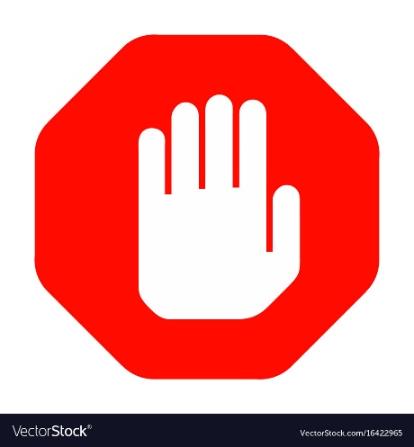
STOP!

BUILDING ELEVATOR PROTOCOL
To slow the spread of coronavirus (COVID-19), Building Management is following guidance from Health Canada and working with provincial and local public health authorities to implement precautions.

MAINTAIN A SAFE DISTANCE:

The COVID-19 virus is most commonly spread from an infected person through:
- Respiratory droplets when you cough or sneeze
- Close personal contact such as touching or shaking hands
- Touching something with a virus on it and then touching your eyes, nose or mouth before washing your hands

Please maintain a safe social distance from others while riding in the elevator.

DO NOT OVERLOAD THE ELEVATOR:

Elevator service is critical for residents with limited mobility. Elevator repairs may take longer during the current COVID-19 environment. Please do not overload or damage the elevators.

RESPECT YOUR NEIGHBOURS & STAFF:

If you have cold or flu-like symptoms, whether or not you have tested positive for COVID-19, please be considerate of your fellow residents and our staff. Please take the necessary precautions to avoid the spread of germs to your fellow residents and our employees. Please contact your local Public Health Authority if you are exhibiting cold or flu-like symptoms.

QUESTIONS AND CONTACT INFORMATION:
Public Health Authorities:
https://www.who.int/emergencies/diseases/novel-coronavirus-2019
https://www.canada.ca/en/health-canada.html

MetCap Customer Service: 1-877-638-2271


