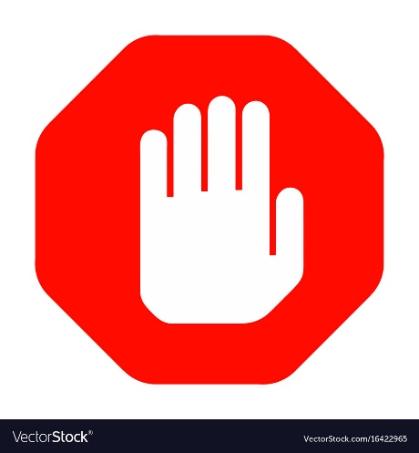
STOP!

BUILDING OFFICE PROTOCOL
To slow the spread of coronavirus (COVID-19), Building Management is following guidance from Health Canada and working with provincial and local public health authorities to implement precautions.

IF YOU ARE A GUEST OR CONTRACTOR:

DO NOT enter this office without written approval from Building Management if you:
- Have tested positive for COVID-19
- Have traveled outside of Canada and not self-isolated for a period of 14 days
- Have been in close contact (i.e. within 6 feet) of someone who has tested positive for COVID-19

IF YOU ARE A RESIDENT:

DO NOT enter this office but instead notify MetCap Customer Service at 1-877-638-2771 if you:
- Have tested positive for COVID-19
- Have traveled outside of Canada and not self-isolated for a period of 14 days
- Have been in close contact (i.e. within 6 feet) of someone who has tested positive for COVID-19

By notifying us of your circumstances we can take appropriate measures to help protect you, our other residents and employees.

COMMON AREAS:

If you have cold or flu-like symptoms, whether or not you have tested positive for COVID-19, please be considerate of your fellow residents and our employees and call MetCap Customer Service at 1-877-638-2771, rather than enter this office in person.

QUESTIONS AND CONTACT INFORMATION:
Public Health Authorities:
https://www.who.int/emergencies/diseases/novel-coronavirus-2019
https://www.canada.ca/en/health-canada.html

MetCap Customer Service: 1-877-638-2271


